CREATE OR REPLACE PACKAGE curs_pkg IS

CURSOR emp_curs IS SELECT employee_id FROM employees1

ORDER BY employee_id;

PROCEDURE open_curs;

FUNCTION fetch_n_rows(n NUMBER := 1) RETURN BOOLEAN;

PROCEDURE close_curs;

END curs_pkg;

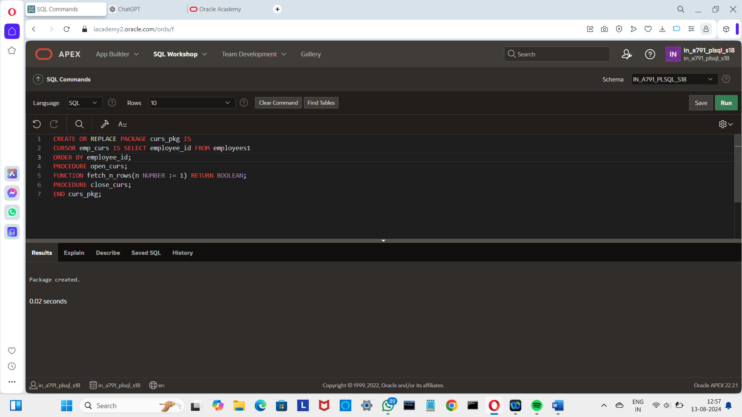

CREATE OR REPLACE PACKAGE BODY curs_pkg IS

PROCEDURE open_curs IS

BEGIN

IF NOT emp_curs%ISOPEN THEN OPEN emp_curs; END IF;

END open_curs;

FUNCTION fetch_n_rows(n NUMBER := 1) RETURN BOOLEAN IS

emp_id employees1.employee_id%TYPE;

BEGIN

FOR count IN 1 .. n LOOP

FETCH emp_curs INTO emp_id;

EXIT WHEN emp_curs%NOTFOUND;

DBMS_OUTPUT.PUT_LINE('Id: ' ||(emp_id));

END LOOP;

RETURN emp_curs%FOUND;

END fetch_n_rows;

PROCEDURE close_curs IS BEGIN

IF emp_curs%ISOPEN THEN CLOSE emp_curs;

END IF;

END close_curs;

END curs_pkg;

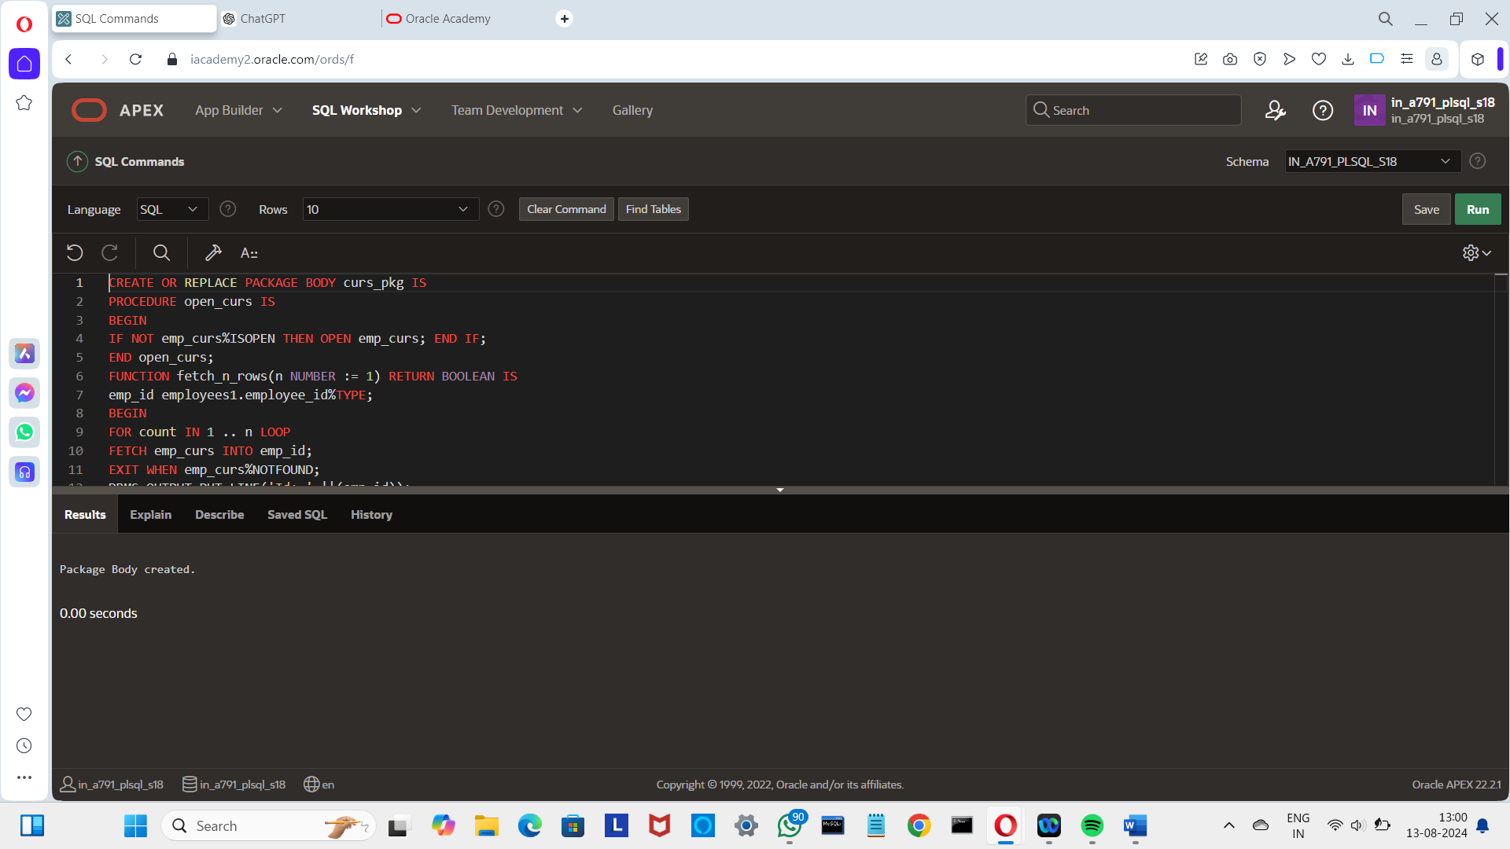

DECLARE

v_more_rows_exist BOOLEAN := TRUE;

BEGIN

curs_pkg.open_curs;

LOOP

v_more_rows_exist := curs_pkg.fetch_n_rows(3);

DBMS_OUTPUT.PUT_LINE('-------');

EXIT WHEN NOT v_more_rows_exist;

END LOOP;

curs_pkg.close_curs;

END;

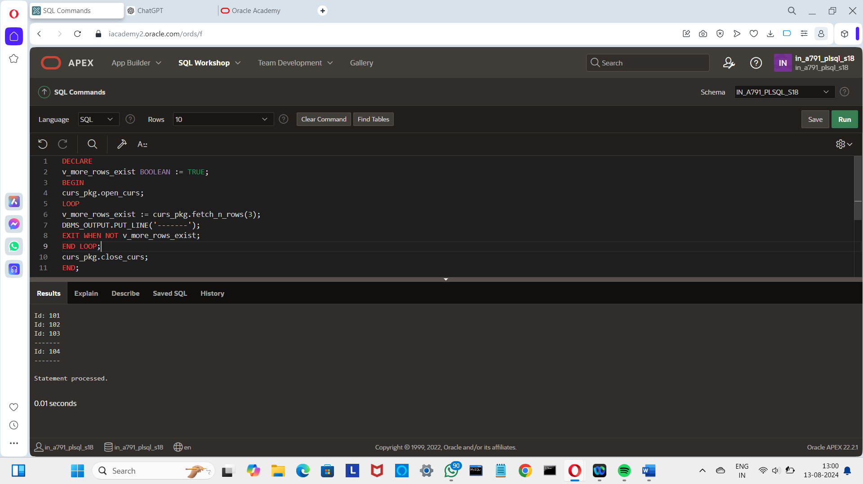

GRANT EXECUTE ON global_consts TO in_a791_plsql_s17;

